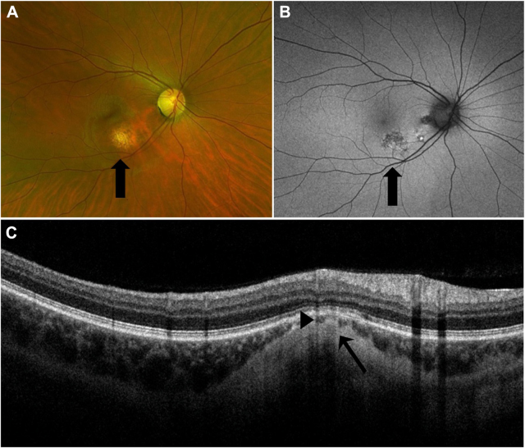

A 32-year-old woman presented to the emergency department with a severe reaction to eyelash extensions. On ophthalmic examination,vision was 20/20. Slit-lamp examination of the posterior segment revealed an incidental finding of a yellow-white, elevated, round lesioninferior to the macula (A, arrow). Fundus autofluorescence imaging showed an area of speckled hypo-autofluorescence (B, arrow). OCTdemonstrated that the lesion was confined to the sclera (C, arrow), with thinning of the overlying choroid (C, arrowhead). Based on the provided images and clinical description please make an ophthalmic diagnosis for this patient. And output the diagnostic conclusions only.

**Posterior scleral plaque**